TOPIC – Data Analysis on Netflix Shows
Submitted To:- Mrs Deepika Tiwari Submitted By:- kartikeya kumar Agnihotri (202410101150077)
Avinash Mishra (202410101150089)
Course:-B-Tech CS(DS+AI)
Group:-33

PROJECT OF DATA ANALYSIS AND REPORTING

INTRODUCTION
Dataset : Netflix ShowsProgramming Language- PythonLibraries Used(Analysis and visualization) - pandas, matplotlib
Step 1: load the csv file
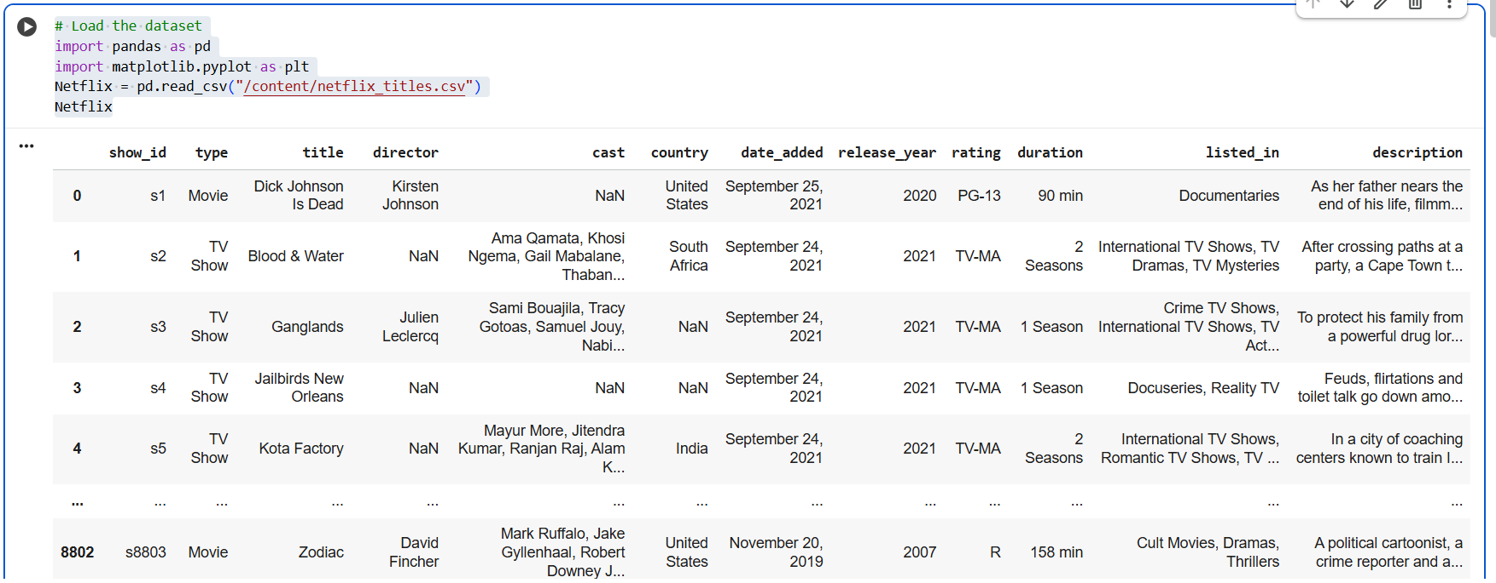

step 2 : Data inspection and exploration

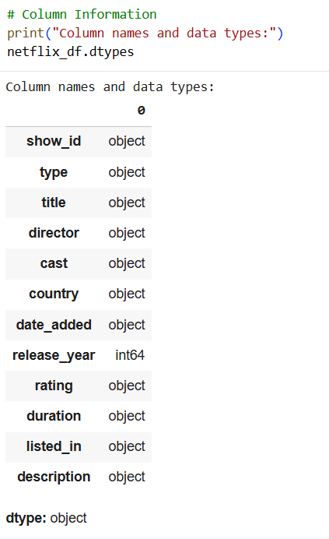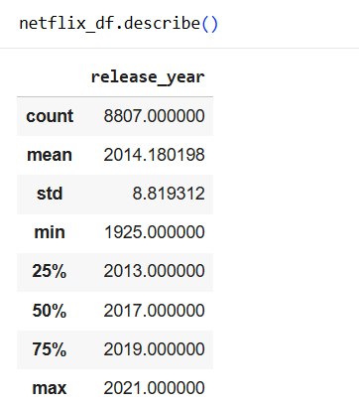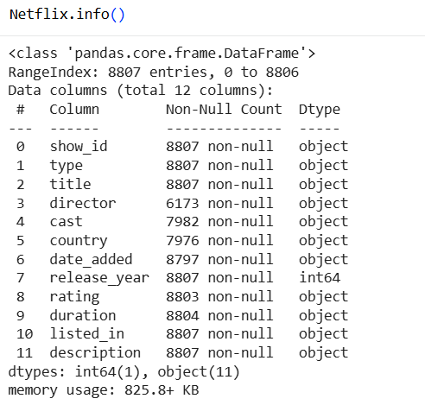

- Step 3 MISSING VALUEs
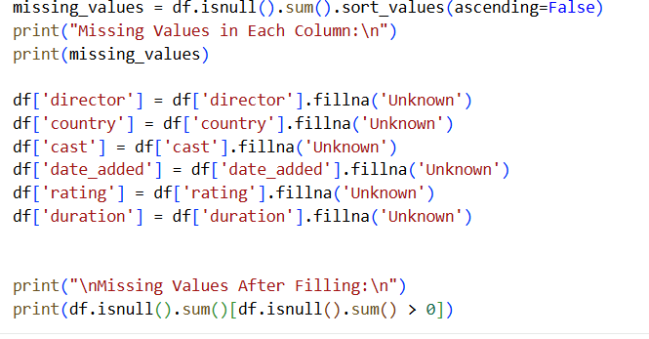

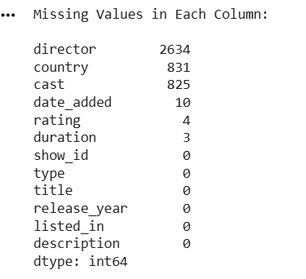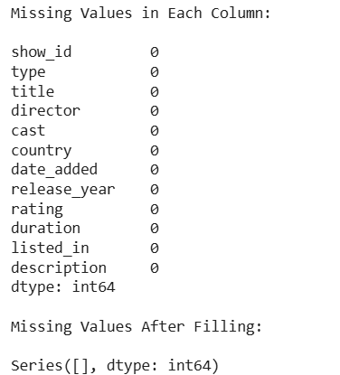

Step 4: Count of Movies vs TV Shows
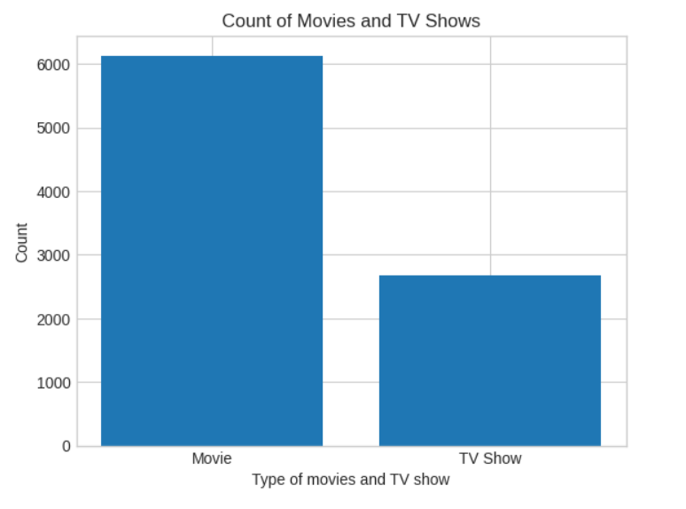

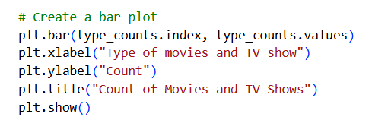

Step 5: Distribution of Movie Durations

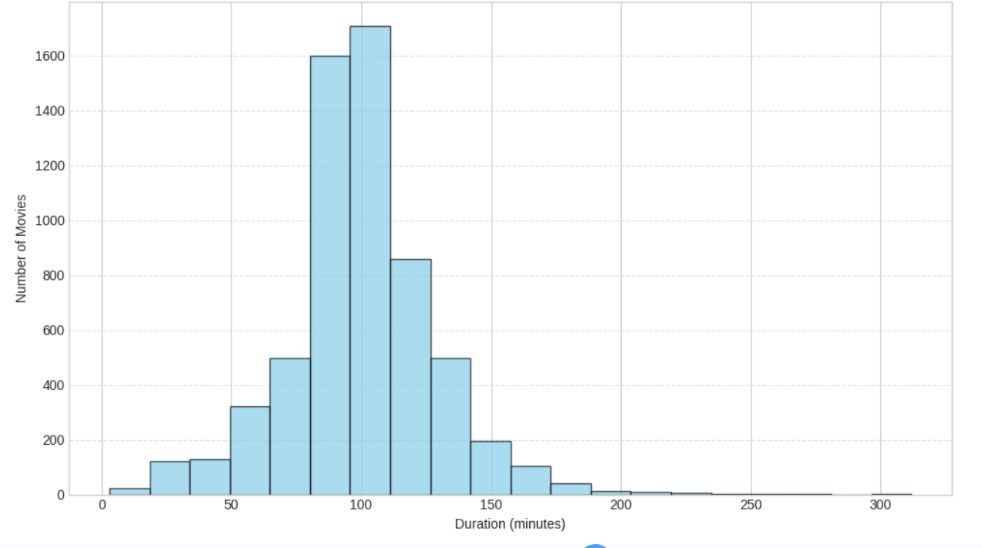

Step 6: Genre and Content Analy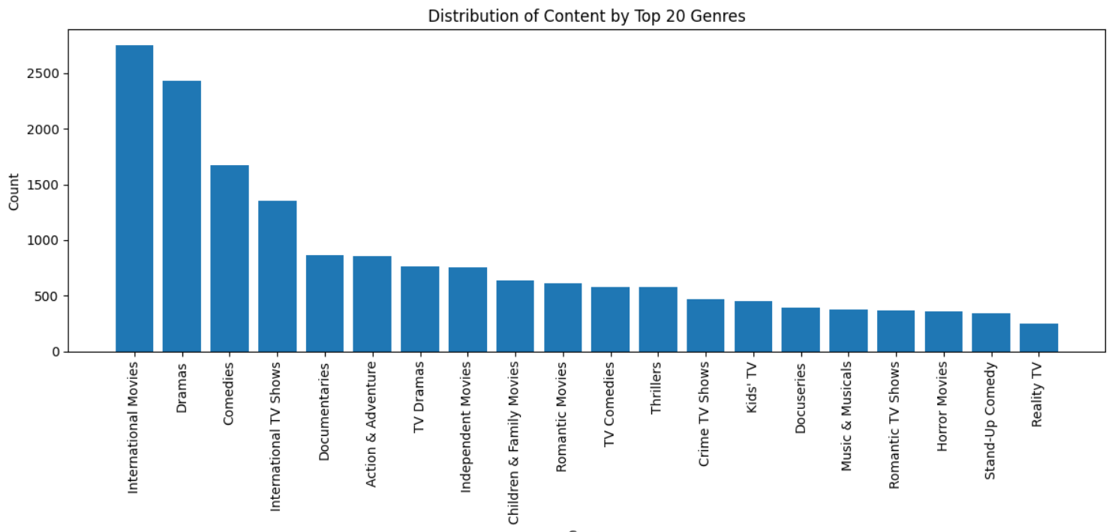

1. The most common genre on Netflix is “International Movies”, followed by “Dramas” and “Comedies.”2. Less frequent genres include Stand-Up Comedy, Reality TV, and Horror Movies.

Step 7: Top 10 Countries Producing Netflix Content
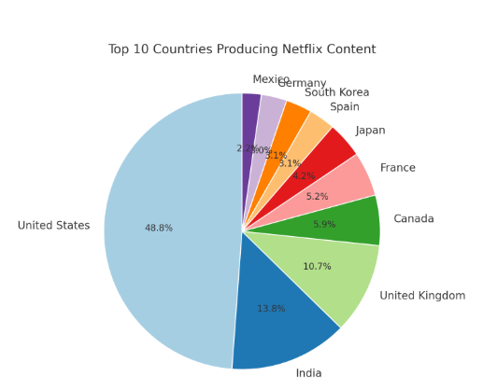

1. The United States contributes the largest share of Netflix content.
2. Countries like Japan, South Korea, and Spain have smaller yet noticeable portions — showing regional content diversity.
Step 8: Number of Titles Added to Netflix Each Year
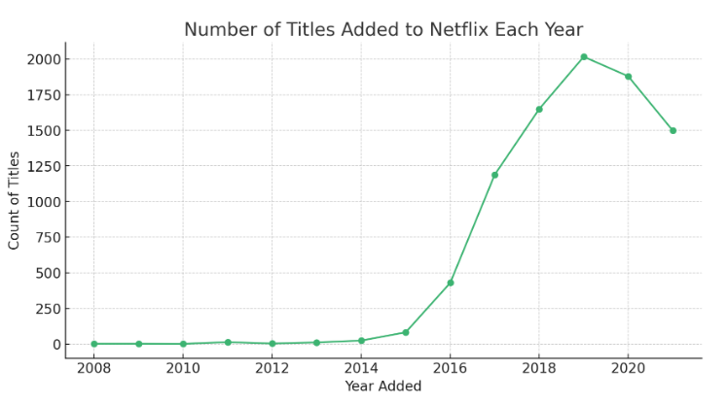

Netflix’s content library grew slowly between 2008 and 2014, as it was still expanding globally.The number of titles added peak around 2019–2020, showing the platform’s most active growth phase.

Final Insights
The United States produces the most content, followed by India and the United Kingdom, showing Netflix’s strong global footprint.Rapid growth after 2015 — the number of titles added increased sharply as Netflix expanded into original productions and new markets.Movie durations typically range from 80–120 minutes, representing standard feature-length films.

